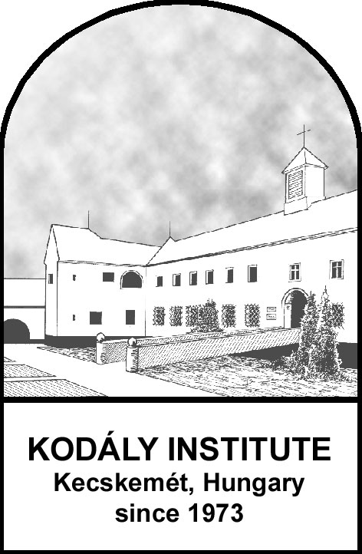 | Kodály Institute  of the Liszt Ferenc Academy of Music  Kecskemét, Hungary  QUESTIONNAIRE  relating to studies at the Kodály Institute
- Family name (as it written in your passport):
- Given name(s) (as it is written in your passport):
- Date of birth:
- Place of birth (town and country):
- Mother’s family name (the one she was born with):
- Mother’s given name (the one she was born with):
- Gender: Male:  Female:  Other: 
- Nationality:
- Native language:
- Command of other languages:
- Permanent Home address:
- E-mail address:
- Phone:
- Passport number:
- Passport expiry date:
- Current Residence address (if different from Permanent Home address):
- Name, address and phone number of the person to be notified in case of emergency:

- Details of secondary school graduation or highest completed degree:
- name of the school:
- location of the school (town and country):
- date of graduation (day, month, year):
- number of the certificate:
- Main instrument:
- Second instrument, if any:
- Profession or occupation:
- Current school / workplace:
- Referees with email addresses (one of them should be from current school/employer):
1.
2.
- Allergies, disabilities, access requirements or any medical conditions that we should know about?

- Request for housing:
1st choice: single room  double room  triple room 
2nd choice: single room  double room  triple room 
- Have you ever been to Hungary? If so, in which capacity?

- Please describe in a few words why you wish to study at the Kodály Institute in Kecskemét, Hungary?

- Knowledge about the Kodály Institute, Kecskemét, if any:

- How do you plan to cover your tuition fees and other expenses during your stay? (self-financing, family, scholarship, etc.)
- Please tell us how you learned about the Kodály Institute:
◻ my university/college □ the Kodály Society in my country
◻ a former Kodály Institute student □ friends, colleagues, fellow students
◻ the Kodály Institute website □other (please specify):
□ the International Kodály Society

Date:
Signature:

